Integration

1. Integration method

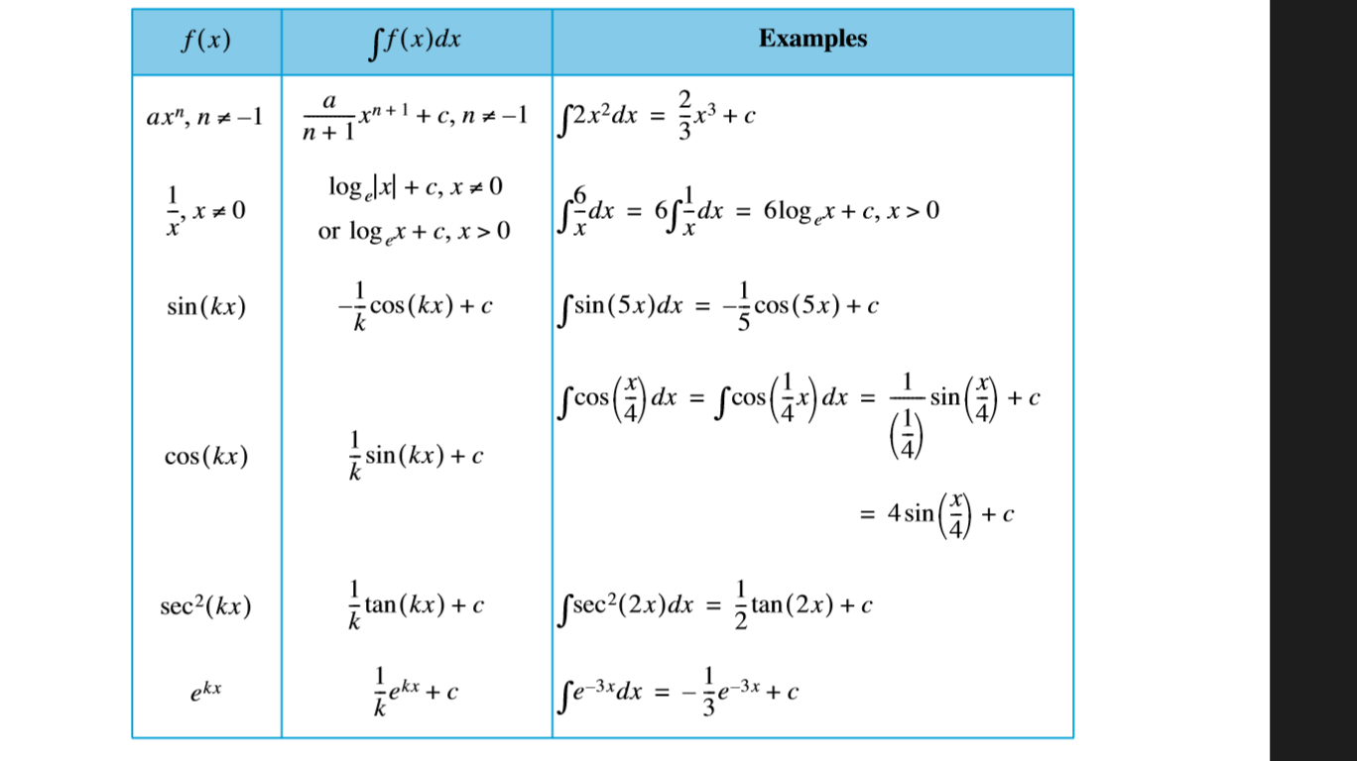

or you may use substitute with u method

Practice Question

1. 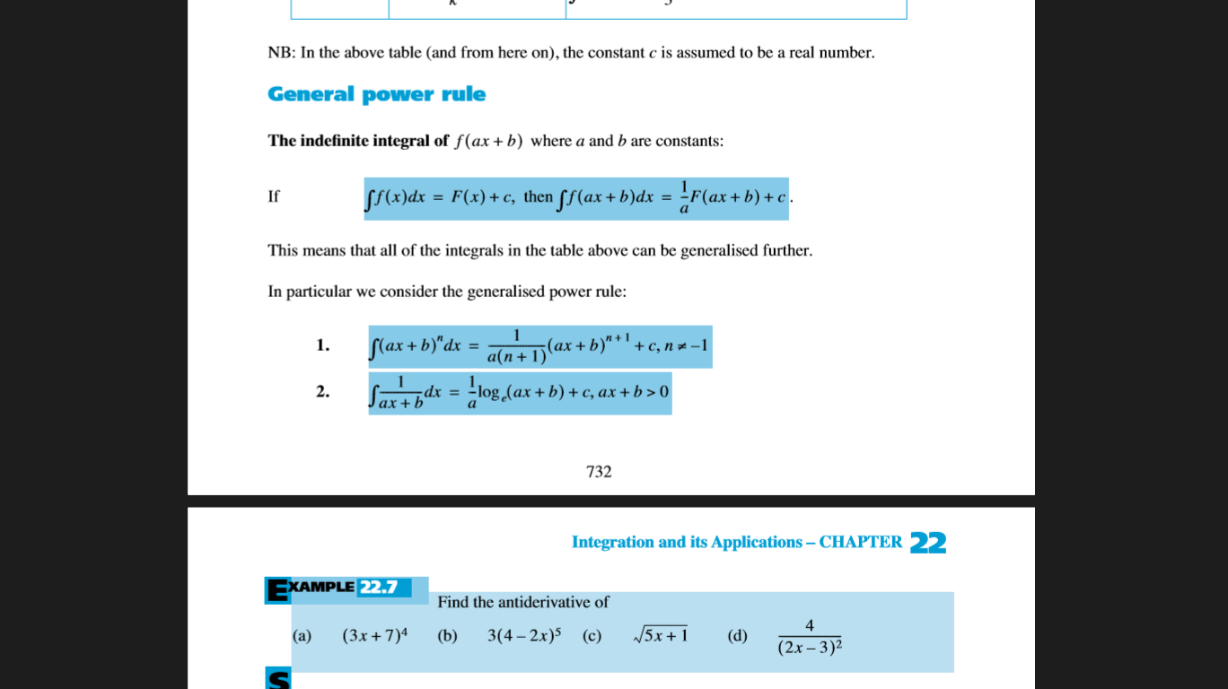
2. 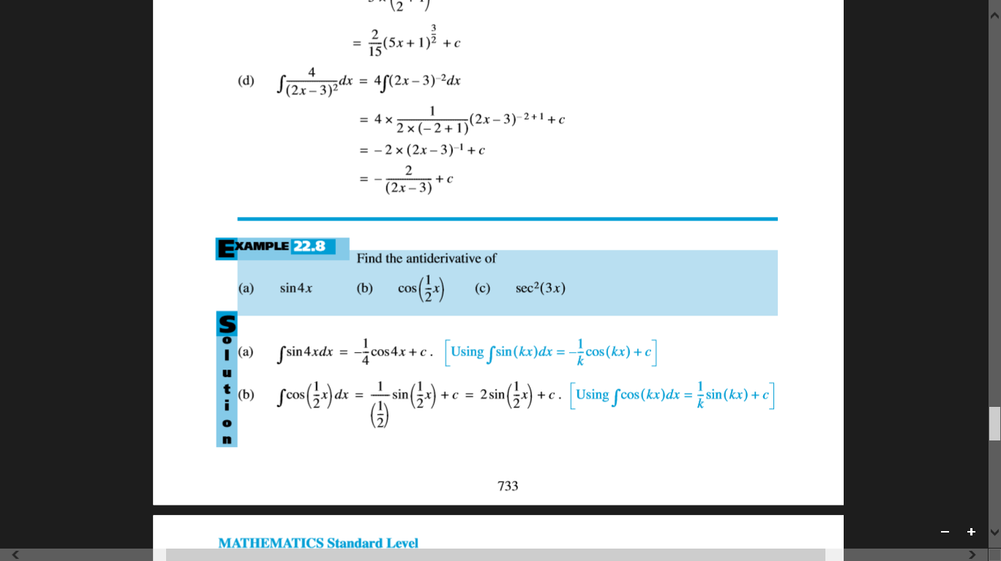
3. 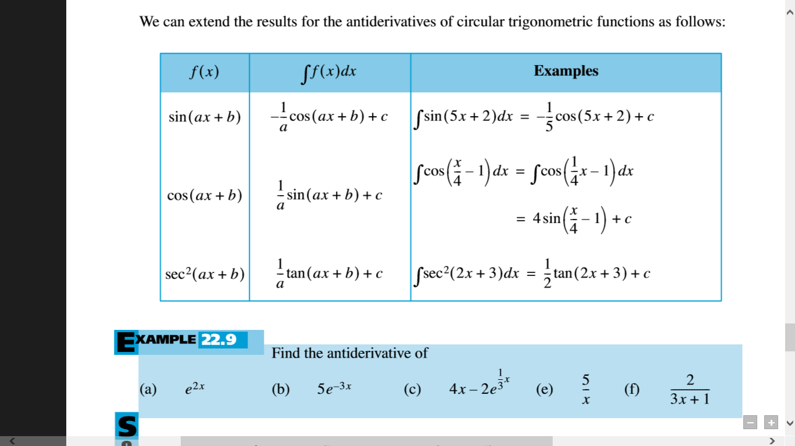

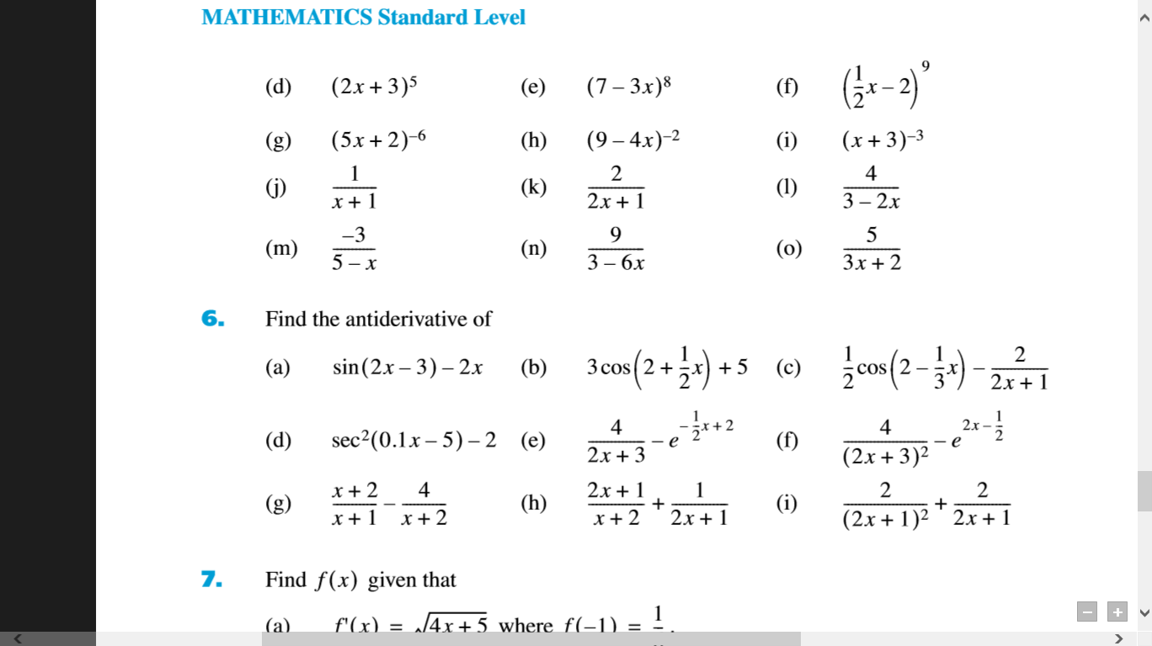

1. Find the exact value of the following: **(4 marks each)**

(a) 

(b) 

(c) 

1. The function *f* is given by *f*(*x*) = 2sin(5*x* – 3).
2. Find *f "*(*x*).
3. Write down .

(Total 6 marks)

1. (a) Find , giving your answer in terms of *m*.

(b) Given that  = 1, calculate the value of *m*. **(Total 6 marks)**

1. Find (a)  (b) . **(Total 4 marks)**
2. Let *f*(t) =  **(Total 3 marks)**
3. Property of Integration

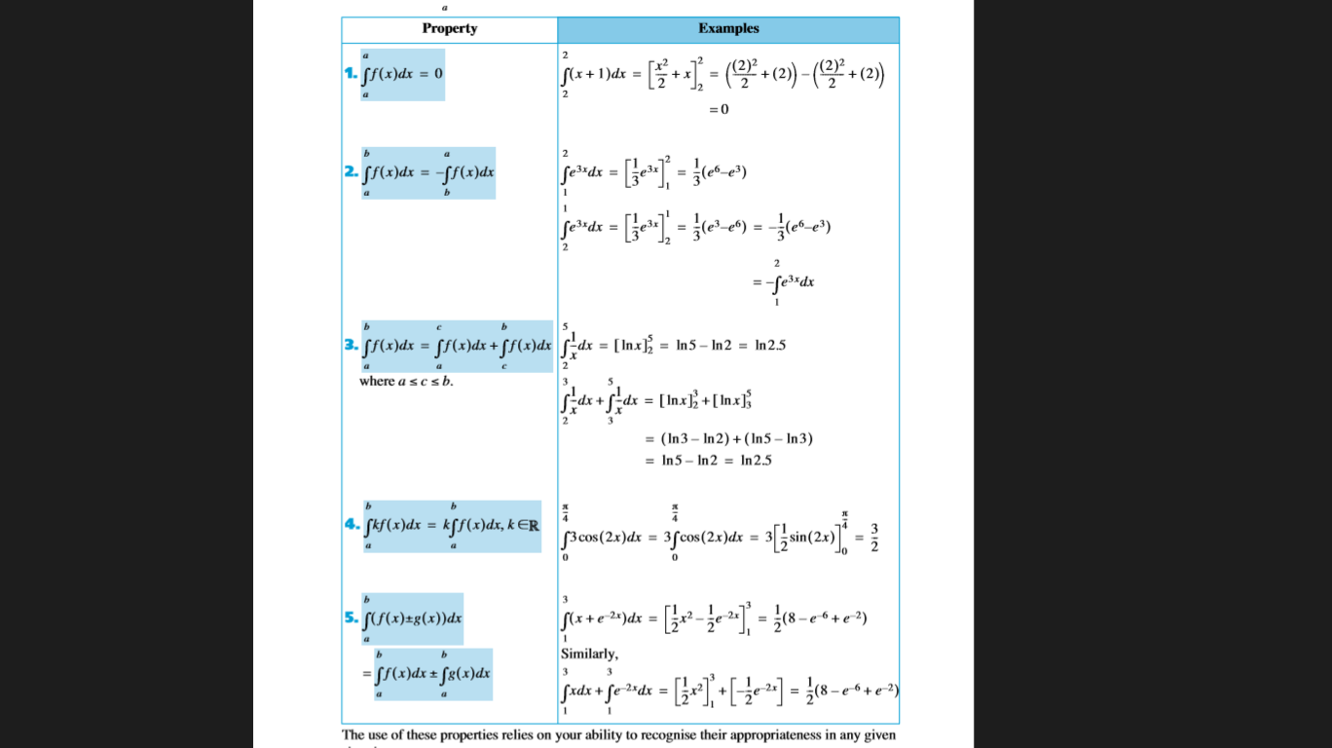

Exercise

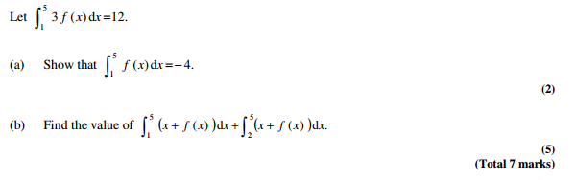

1. The table below shows some values of two functions, *f* and *g*, and of their derivatives *f*  and *g* .

|  |  |  |  |  |
| --- | --- | --- | --- | --- |
| *x* | 1 | 2 | 3 | 4 |
| *f*(*x*) | 5 | 4 | –1 | 3 |
| *g*(*x*) | 1 | –2 | 2 | –5 |
| *f* (*x*) | 5 | 6 | 0 | 7 |
| *g* (*x*) | –6 | –4 | –3 | 4 |

Calculate the following.

(a) (*f*(*x*) + *g*(*x*)), when *x* = 4;

(b) .

(Total 6 marks)

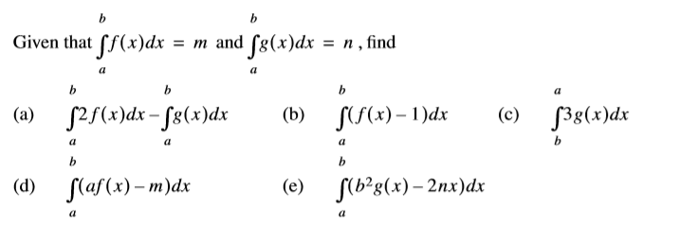

1. Finding the Area

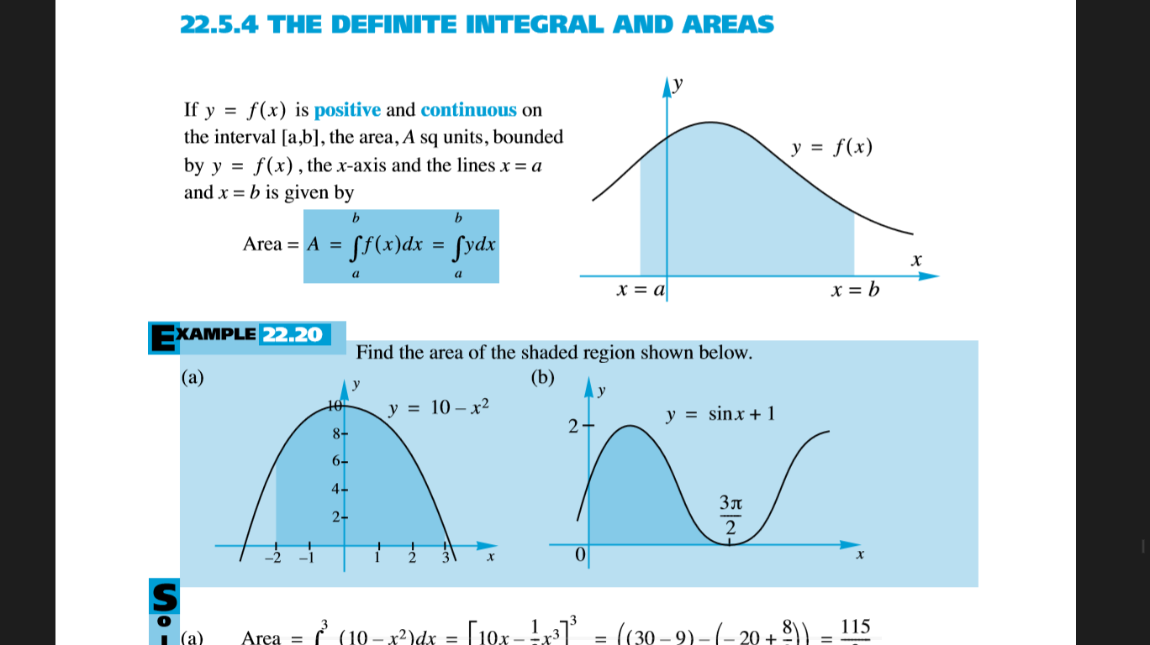

Example1: find the area of shaded area below



Example2: 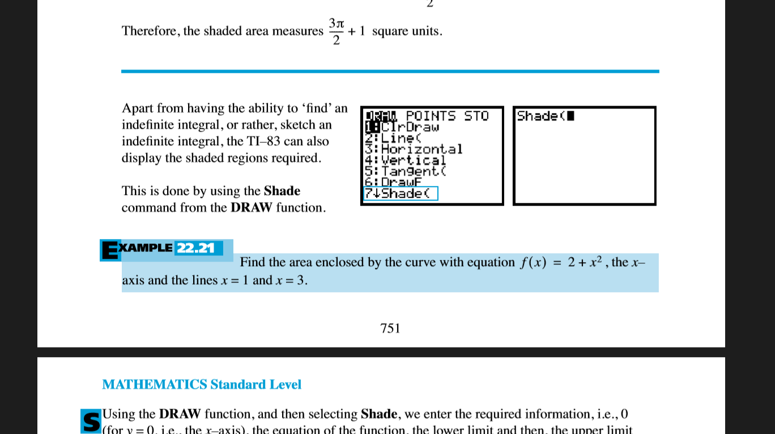

Integration respect to y-axis

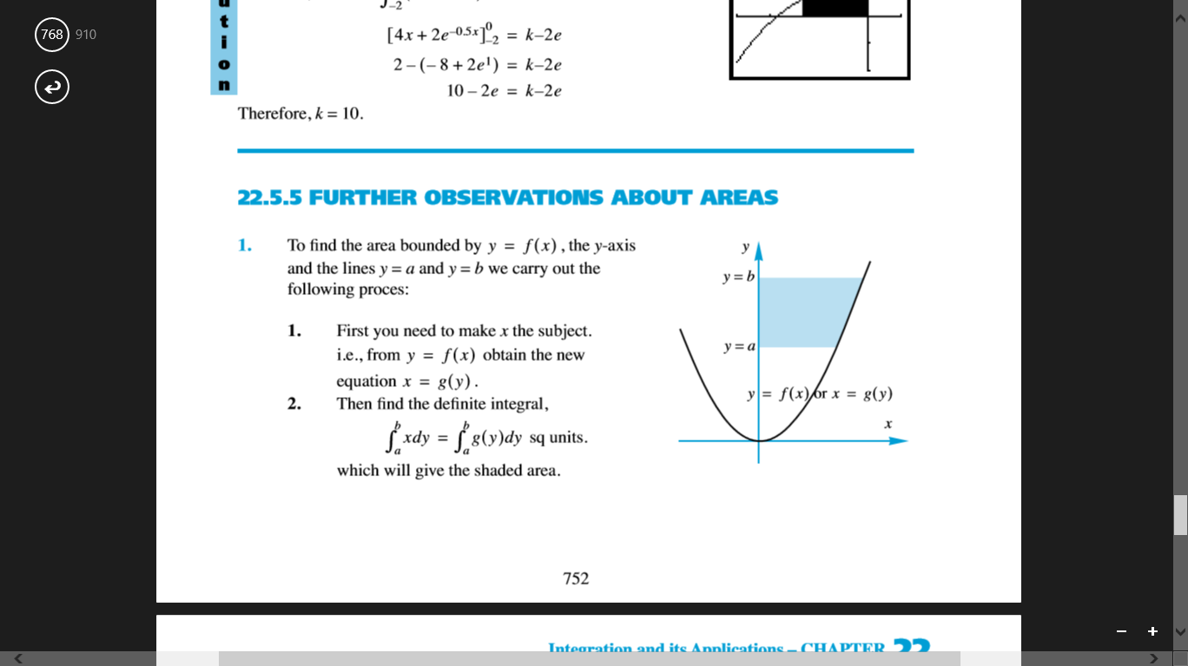

Example: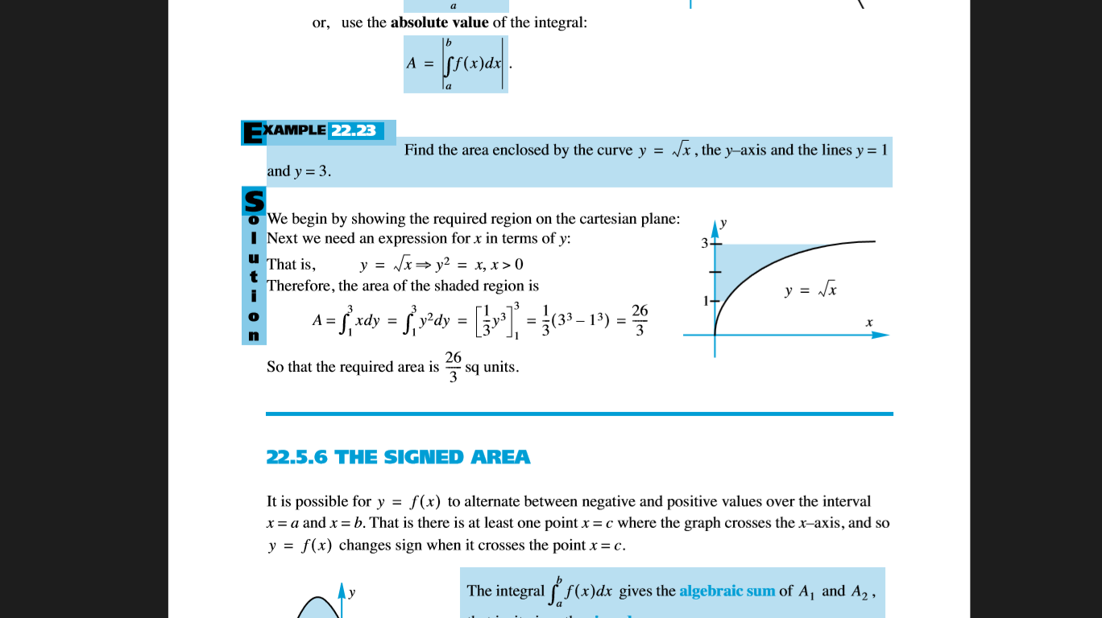

Integration respect to y-axis

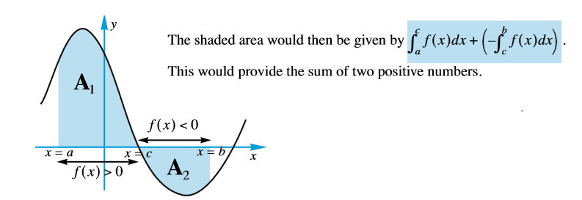

Example: 

Example: 

Find the area between 2 curves

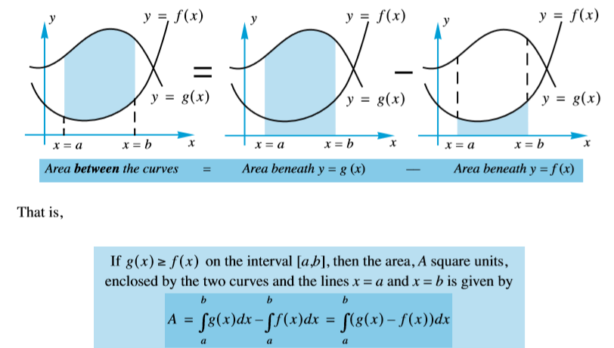

Example : 

Practice Questions:

1. 
2. 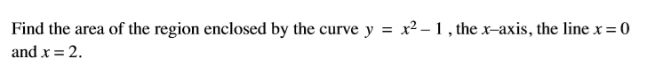
3. 